# Software Development Process

This document describes software development process.

## Summary

Software development process has following 3 steps:

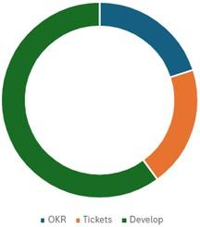

| **Step** | **Purpose** | **Details** |
| --- | --- | --- |
| 1. | Define OKR | Business, Product, Architects and Team Leads will define [OKR](https://marketplace.atlassian.com/apps/1219988/okr-board-for-jira-by-oboard) or what business wants to achieve in next 3 months. This could be done by having a week long workshops. The outcome of these workshops should be a list of quarterly OKRs. |
| 2. | Create Tickets | Product will create tickets that map to a KRs. Tickets will be prioritized and assigned to one of 6 sprints of a quarter each sprint spanning 2 weeks.  Margin of bug fixing, production hot fixes, procurement delays, cross team delays, research, skill development etc. will be maintained in planning. |
| 3. | Develop Tickets | During this step product will write requirement document, UX will create wireframes, architects will write HLA (High Level Architecture), team leads will write LLD (Low Level Design), developers will write and test code, devops will deploy code, QA will test code, developers will fix bugs. |

## Define OKR

OKR (objectives and key results) requires following work to be done:

1. Decide OKR Intervals (quarterly, bi-yearly, yearly)
2. Structure OKR (Company, Group, and Personal)
3. Separate OKR into Groups (Departments, teams, or other organizational units)
4. Create Objectives and Key Results
5. Align Your Work in Jira with OKRs
6. Set Up an Executive and Team Dashboards
7. Embed OKR reports into Confluence

Find detail at [https://oboard.io/blog/how-to-implement-okrs-in-jira-a-practical-guide-for-](https://oboard.io/blog/how-to-implement-okrs-in-jira-a-practical-guide-for-beginners) [beginners](https://oboard.io/blog/how-to-implement-okrs-in-jira-a-practical-guide-for-beginners)

OKR board bridges the gap between strategy and execution or business stack holders and various teams.

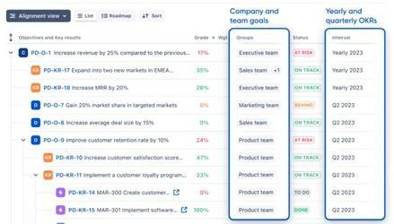

Watch video about OKR at: <https://www.youtube.com/watch?v=s0p5z02_Ceo&t=4s>

We can use Jira to setup OKR [https://moduscreate.com/blog/implement-okrs-with-jira-and-](https://moduscreate.com/blog/implement-okrs-with-jira-and-confluence/) [confluence/](https://moduscreate.com/blog/implement-okrs-with-jira-and-confluence/)

## Meetings

We will add following important OKR ceremonies in a quarterly OKR drive. Note that, all times are in (GMT)

| **Name** | **Day/Time** | **Duration** | **Participants** | **Purpose** |
| --- | --- | --- | --- | --- |

| Create OKR | Every 1st Monday, Tuesday, Wednesday of quarter at 9AM | 4 session 45min each for 3 days in first half of the day | Business Product Tech  Hosted by Business Lead | Business, Product and Engineering teams will get together to understand the key areas where business wish to grow and wanted to make progress. |
| --- | --- | --- | --- | --- |

## Create Tickets

Tickets are sacred, because it is a unit of work and this is where business time and money goes. If we choose to carefully established well-defined tickets, business will win. On the other hand if we define thousands of tickets and sub-tasks, we may end up creating no business value while still busy.

Each ticket requires creation, analysis, story pointing, planning, development and lots of other activities. Being careless about tickets and having tickets for the sake of tickets has a potential to create thousands of tickets and then spending time and money on their analysis, story pointing, planning, development and myriad of other activities. So only product team will carefully define necessary tickets using OKRs. More specifically:

1. Architects, Developers, DevOps and Team Leads can not create tickets. For any new ticket creation contact product team. Only product team will create tickets aligned with OKRs.
2. There will be no ticket for spikes or research. Rather a confluence document link to any kind of research will be added as a comment to OKR ticket.
3. There will be no sub-ticket without task parallelism. Instead tickets should follow assembly line process from Todo to UX, Architecture(HLA, LLD), DevOps, Development, QA, Deploy, Done

### Ticket Do’s and Don’ts

1. Scrum Master should clarify before the start of each Sprint that
   1. Frontend, Backend and DevOps can not create Tasks, Sub-Tasks or any Todo in Jira
   2. Frontend, Backend and DevOps can not modify Sprint in any way
   3. Frontend, Backend and DevOps can only comment in tickets and change the status of ticket
2. Only product team
   1. can create tickets, add description, set priorities and select tickets for Sprints.
   2. can add new Tasks in Sprint/Backlog or move tickets between Sprints.
   3. Only QA team can add bugs in backlog. All else should slack bugs to QA. This will help us to avoid time and money on lots of duplicate issue.

### Ticket Workflow

Ticket has following workflow:

#### Todo

If Product Specs are created or there is a problem in Specs, set ticket status to Todo. This step is not completed if Specs document URL textbox in ticket is empty and ticket is not moved to UX.

#### UX

If UX is created or there is a problem in UX, set ticket status to UX. This step is not completed if UX URL textbox in ticket is empty and ticket is not moved to **Architecture**.

#### Architecture

If HLA and LLD work is required on ticket, set ticket status to Architecture. This step is not completed if Architecture document URL textbox in ticket is empty and ticket is not moved to **DevOps**.

#### DevOps

If DevOps work is required on ticket, set ticket status to DevOps. This step is not completed if DevOps does not make a comment ‘**DevOps completed**’ and ticket is not moved to **Backend**. The ticket must be reviewed by DevOps Lead or 2 senior members before it is marked as completed.

#### Backend

If Backend work is required on ticket, set ticket status to Backend. This step is not completed if Backend does not make a comment ‘**Backend completed**’ and ticket is not moved to **Frontend**. The ticket must be reviewed by Backend Lead or 2 senior members before it is marked as completed.

#### Frontend

If Frontend work is required on ticket, set ticket status to Frontend. This step is not completed if Frontend does not make a comment ‘**Frontend completed**’ and ticket is not moved to **QA**. The ticket must be reviewed by Frontend Lead or 2 senior members before it is marked as completed.

#### QA

If QA is required on ticket, set ticket status to QA. This step is not completed if QA does not make a comment ‘**QA completed**’ and ticket is not moved to **Done**.

#### Done

If QA verifies/resolves/closes a ticket, set ticket status to Done

### Ticket Priority

We will use Backlog Refinement and Sprint Planning to decide the priority.

### Use @ tags

Use @ in comments so people are notified. Use @ as much as required.

### Use Labels

1. Product team will create Topic labels like **o2-to-o4** as needed and will update the team in Daily meeting or via slack.
2. Add topic labels in order of priority in Sprint objectives textbox while starting a sprint.
3. If a team member from specific team has worked on a ticket, select appropriate label. For example, if product team has worked on **TK-228**, it will select ‘**Product**’ label from Labels dropdown. Same goes true for other teams:
   1. Product
   2. UX
   3. Architecture
   4. DevOps
   5. Frontend
   6. Backend
   7. QA
4. If developer has resolved a bug, add a comment in ticket to specify resolution and:
   1. Select a label **Bug-Fixed** if bug is Fixed
   2. Select a label **Bug-Duplicate** if bug is Duplicate
   3. Select a label **Bug-Not-Reproducible** if bug is not Reproducible
   4. Select a label **Bug-Wont-Fix** if bug is not to be Fixed

Product team will add tickets in Sprint before 6PM every Friday for next Sprint (e.g. Sprint-3):

1. For every new requirement to be developed, product team will add a ticket in next available Sprint
2. Teams will select tickets based on priority and capacity.
3. So, if there are 20 High priority tickets and a team has the capacity to do 15, it will select 15 tickets only. The remaining will be done in the following Sprints. If team has more capacity than tickets, it will take tickets from the next Sprint (e.g. Sprint-3) or Backlog
4. Set Priority:
   1. Highest Priority = app crash or security hot fix should be completed today
   2. High Priority = Should be completed in this Sprint if possible or next sprint
   3. Medium Priority = Should be completed as soon as possible

## Develop Tickets

### Meetings

We will add following important Scrum ceremonies in a two-week sprint. Note that, all times are in (GMT).

| **Name** | **Day/Time** | **Duration** | **Participants** | **Purpose** |
| --- | --- | --- | --- | --- |
| Backlog Refinement | Every Thursday 11AM | 45min | Product Tech  Hosted by Scrum Master | Product and engineering team get together to understand requirements and assign Story Points. |
| Sprint Planning | Once a Sprint on Monday 9AM | 45min | Tech Team  Hosted by Scrum Master | Select tickets based on team’s Story Point capacity. |
| Daily Standup | Daily 10AM | 30min | Tech Team  Hosted by Scrum Master | Keep team on track and aligned with OKRs. |
| Sprint Review | Once a Sprint on Friday 11AM | 30min | Product  Tech Hosted by  Scrum Master | Demonstrates what has been completed from OKRs |
| Sprint Retro | Once a Sprint on Friday 11:30 AM | 30min | Team  Hosted by Scrum Master | Feedback on how team is going. |

### Backlog Refinement

Backlog refinement is a combined activity from Product and Engineering teams. The Product and Engineering teams reviews and refines from 9 to 30 tickets per 45 min meeting. In this meeting, Product and Engineering will review upcoming sprint or product backlog to ensure that the items are well-defined, and ready to be brought into the sprint during sprint planning. We could have 1 to 3 such meetings per 2 week sprint each lasting for 45 minutes.

Following should be the focus of meeting:

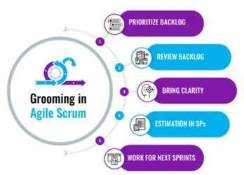

### T-Shirt Sizing

Initiatives especially HLA (High Level Architecture), could be sized based on T-Shirt sizing:

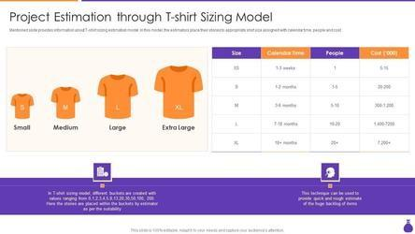

| **Symbol** | **Size** | **Effort** | **People** | **Sprints** |
| --- | --- | --- | --- | --- |
| XS | Extra Small | 1-3 week | 1 | 1 |
| S | Small | 1-2 months | 1-5 | 2-4 |
| M | Medium | 3-6 months | 5-10 | 4-12 |
| L | Large | 7-18 months | 10-20 | 12-18 |
| XL | Extra Large | 18 months+ | 20+ | 18+ |

Scrum teams could use Sprint based T-Shirt sizing while non-scrum projects could be sized based on months, people and cost.

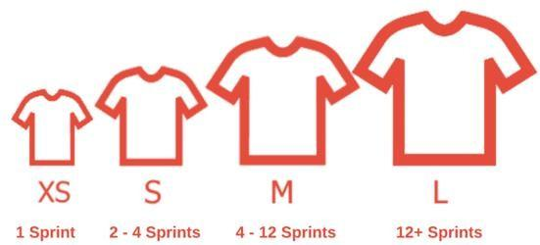

### Story Points

During Backlog Refinement adjust ticket Story Points based on ticket’s complexity and effort required to complete it. If required play [story point poker](https://www.scrumpoker-online.org/) with Estimate Options ?, coffee, 1, 2, 3, 5, 8, 13.

| **Known about the task** | **Dependencies** | **Effort** | **Story Points** |
| --- | --- | --- | --- |
| Everything | None | Less than 2 hours | **1** |
| Almost everything | Almost none | Half a day | **2** |
| Something | Some | Up to two days | **3** |
| Almost nothing | Few | Few days | **5** |
| Nothing | More than Few | Around a week | **8** |
| Nothing | Unknown | More than one week | **13** |

### Sprint Planning

This is the first ceremony of the sprint and sets the direction for the upcoming two weeks. During this meeting, the Scrum team, including the Product Team and Engineering Team, collaboratively define the sprint goals and select tasks and bugs or backlog items to work on during the sprint. They also create a sprint backlog that outlines the tasks necessary to complete these items.

### Daily Standup

A reminder meeting by Scrum Master to update Jira ticket with what you have done on the last day and how you will progress today. Team Lead could drill down and investigate further those tickets which are stalled or are not progressing. Scrum Master will ensure all cross team road blockers are removed as soon as possible.

### Sprint Review

At the end of the two-week sprint on Tuesday, the team will hold a sprint review to demonstrate the completed work to stakeholders. The goal is to gather feedback and ensure the product increment is meeting its objectives. Scrum Master will ask Team how many demos, presentations etc. will be done during review. Usually each demo should be completed within 5- 10min.

### Sprint Retro

Just after the sprint review, the team will conduct a sprint retrospective. In this meeting, the team reflects on the sprint and discusses what went well, what could be improved, and what actions can be taken to enhance the next sprint. This ceremony is crucial for continuous

improvement. Conduct retro using one of the Miro [retro templates.](https://miro.com/templates/retrospective/) To get started, use [Quick](https://miro.com/templates/quick-retrospective/) [Retrospective Template.](https://miro.com/templates/quick-retrospective/) Share retro results in confluence in chronological order.